Advanced Computer Architecture LAB
Autumn Semester 2025-26
Assignment 6
Name – Soham Chakraborty
Roll No – 22CS02002

Ans – a) Initial config_a.cfg file after setting all resources values to 1
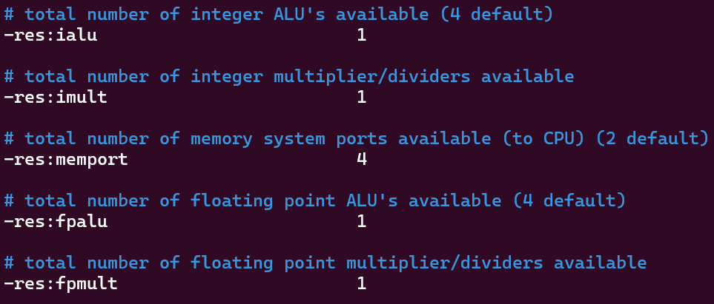
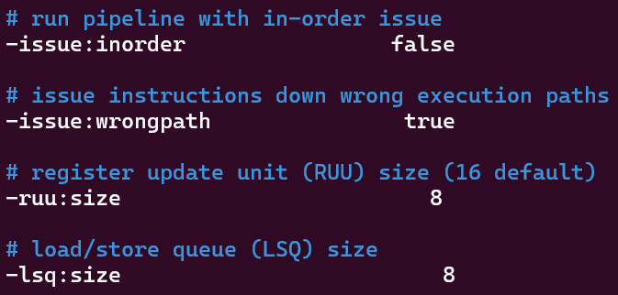

# of resources |  | 1 | 2 | 4
Integer ALU resource | test-math | 0.6950 | 0.8167 | 0.8346
 | test-fmath | 0.6021 | 0.6487 | 0.6592
Integer multiplication resource | test-math | 0.6950 | 0.6809 | 0.6809
 | test-fmath | 0.6021 | 0.5661 | 0.5661
Integer addition +  multiplication resource | test-math | 0.6950 | 0.8167 | 0.8346
 | test-fmath | 0.6021 | 0.6487 | 0.6592
Floating ALU resource | test-math | 0.6950 | 0.6809 | 0.6809
 | test-fmath | 0.6021 | 0.5661 | 0.5661
Floating multiplication  resource | test-math | 0.6950 | 0.6809 | 0.6809
 | test-fmath | 0.6021 | 0.5661 | 0.5661
Floating addition +  multiplication resource | test-math | 0.6950 | 0.6809 | 0.6809
 | test-fmath | 0.6021 | 0.5661 | 0.5661

Observation: We observe that only increase integer ALU increases the IPC both in case of test-math and incase of test-fmath. Moreover increasing integer multiplication and floating resouces we observe a decrease in IPC instead of increase.
Explanation: One possible reason behind no increase in performance other than when integer ALU is increase might be because of the fact that integer ALU operations are bottlenecks in both codes. Hence, even if we were to parallelize the other parts of computation we still have to wait to integer computations to be done. This result directly comes from Amdahl’s Law.
Reason behind decrease in IPC when say, when integer multiply is increased might be because even though integer ALU remains a bottleneck, assigning extra resources to integer multiply results in extra scheduling time and extra overhead with no increase in performance gained due to resources increase.

Ans – b) Code for matrix multiplication –
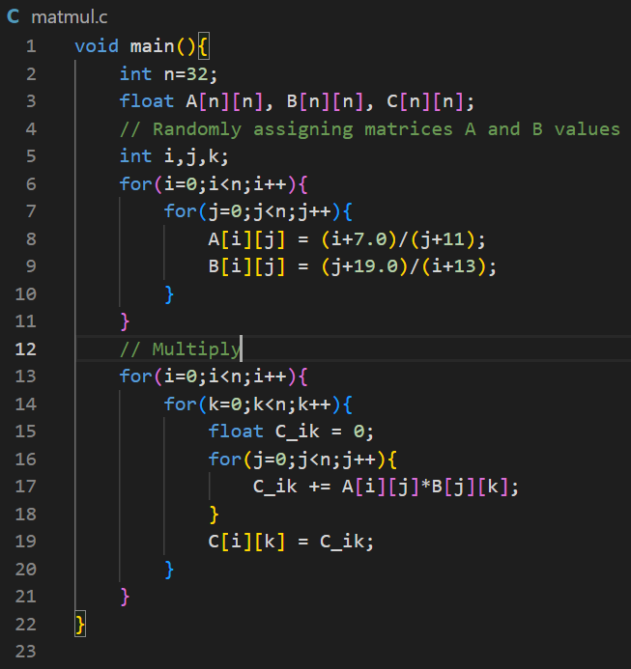

# of resources | 1 | 2 | 4
Integer ALU resource | 1.0056 | 1.2689 | 1.2690
Integer multiplication resource | 1.0056 | 1.0056 | 1.0056
Floating ALU resource | 1.0056 | 1.0056 | 1.0056
Floating multiplication  resource | 1.0056 | 1.0056 | 1.0056

Observation: Similar to last case (a) we again observer that changing integer ALU’s from 1 -> 2 has significant increase in IPC. Changing it again from 2 -> 3 has slight increase.
But once again changing any other type of resources allocated has no impact on IPC.
Explanation: To explain this behavior for all cases we run sim-profiling of the codes to check the integer computations and floating points computations –
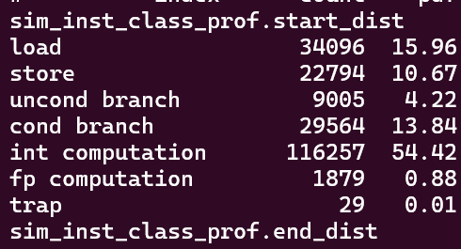
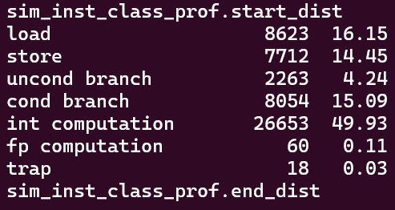

test-math test-fmath

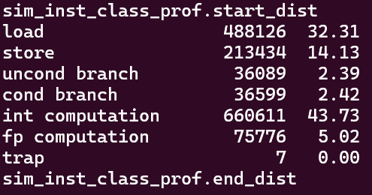

matrix-multiplication

In all of these cases the %age of floating points instructions executed are very low - 0.88% , 0.11% and 5.02% as compared to 54.42%, 49.93% and 43.73% of integer instructions executed.
As a result of this only increasing int ALU’s helps because it remains a bottleneck and has over 10 times more instructions to be executes than floating operations.

